Name Date

Test A

Chapter

8

Determine whether the polygons are similar.

Answers

1.

2.

3.

4.

5.

6.

7.

8.

9.

10.

11.

12.

13.

14.

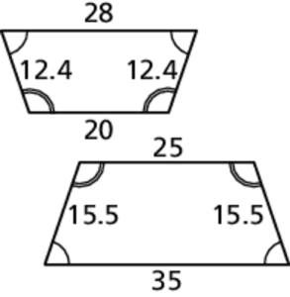 1. 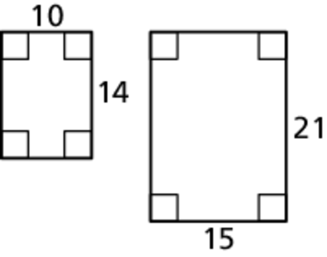 2. 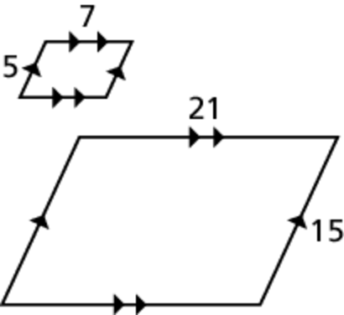 3.

In the diagram,  Find the following. 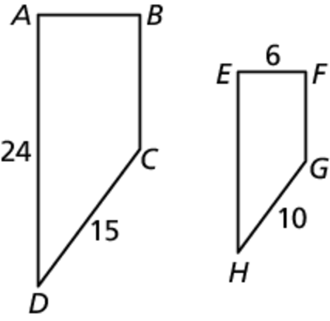

4. scale factor

5. *EH*

6. *AB*

In the diagram,  Complete   
the proportions and congruence statements.

7. 

8. 

9. 

10. Find the value of *x*.

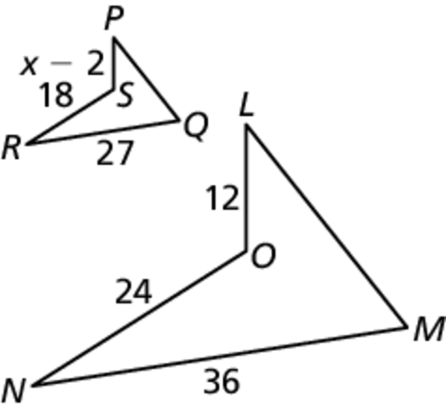Determine whether the triangles are similar. If they are, write a similarity statement. Explain your reasoning.

11. 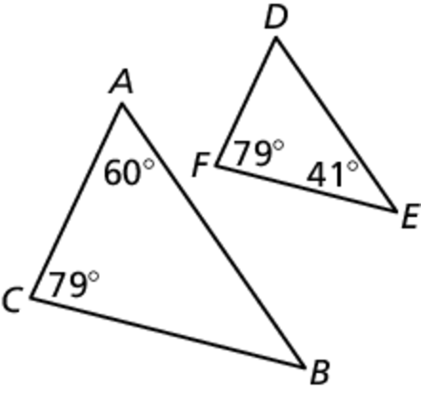 12. 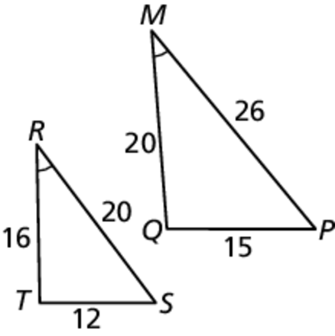 13. 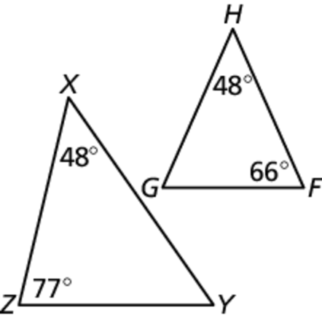

14. Determine whether the triangles with vertices  and  are congruent. Use transformations to explain your reasoning.

Name Date

Test A **(continued)**

Chapter

8

15. Your geometry class goes outside to measure the height of the school’s flagpole. A student who is 5 feet tall stands up straight and casts a shadow   
that is 8 feet long. At the same time the flagpole casts a shadow that is 24 feet long. What is the height of the flagpole?

Find the value of *x* that makes the triangles similar.

Answers

15.

16.

17.

18.

19. See left.

20. See left.

21.

22.

23.

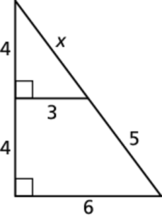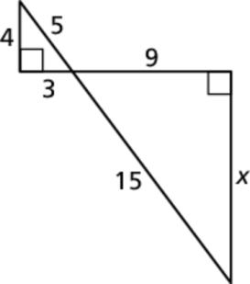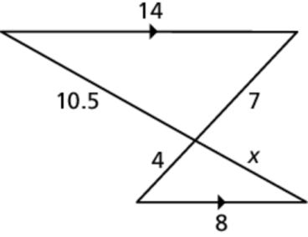 16. 17. 18.

**Graph**  **with vertices**  and its image   
after a dilation with scale factor *k*.

19.  20. 

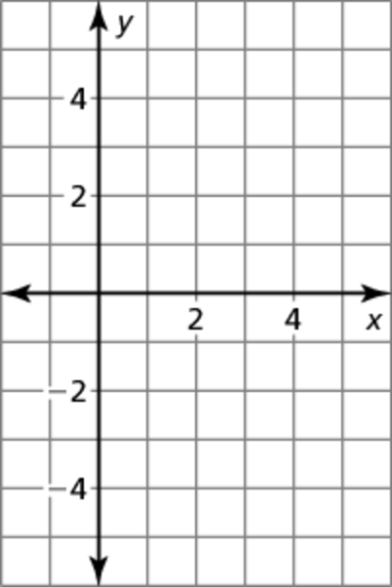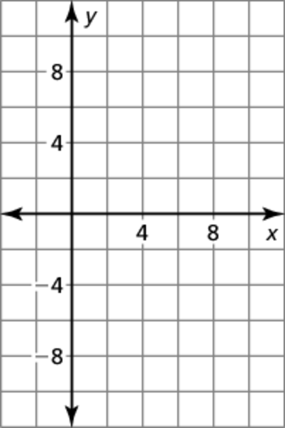

21. and  and  Your partner concludes that the triangles are not similar.   
Do you agree or disagree? Why?

Describe a similarity transformation that maps the preimage to the image.

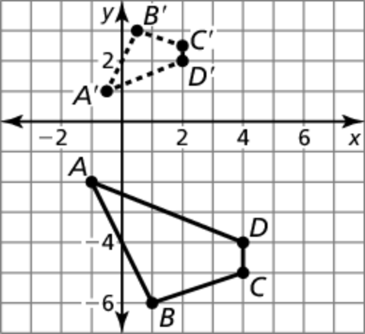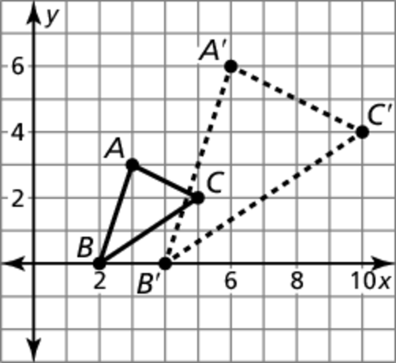 22. 23.