Name Date

Test A

Chapter

7

Find the sum of the measures of the interior angles and the sum of the measures of the exterior angles of the polygon.

Answers

1.

2.

3.

4.

5.

6.

7.

8.

9.

10.

11.

12.

13.

14.

15.

16.

1. 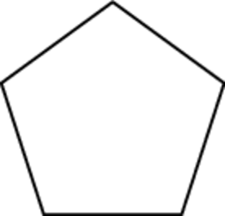 2. 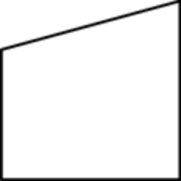 3. 

Find the value of *x*.

4. 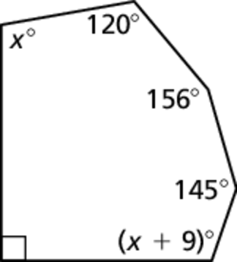 5. 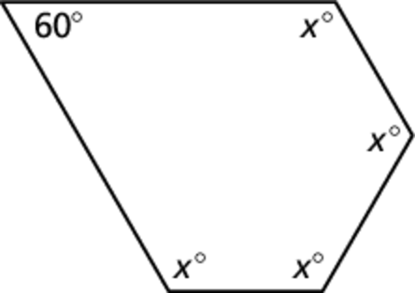

6. Find the measure of each exterior angle of a regular polygon in which the sum of the measures of the interior angles is 

7. What is the sum of the exterior angles in a regular 15-gon?

Find the indicated measure in  Explain your reasoning.

8. *AD* 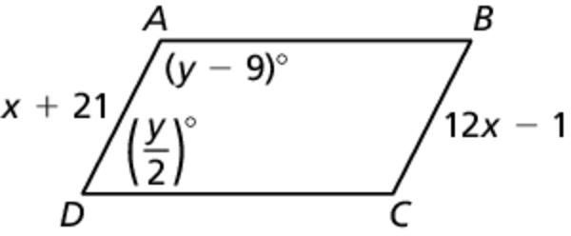

9. 

10. Three vertices of parallelogram *DEFG* are  Find the coordinates of vertex *G*.

Find the indicated measure in parallelogram *STUV*. Explain your reasoning.

11. *TS* 12. *SW*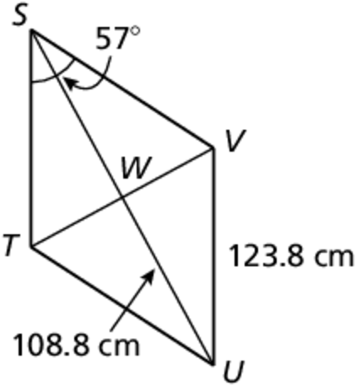

13.  14. 

15. *US* 16. 

Name Date

Test A **(continued)**

Chapter

7

Find the values of *x* and *y* that make the quadrilateral a parallelogram.

Answers

17.

18.

19.

20.

21.

22.

24.

25.

26.

27.

28.

29.

30.

31.

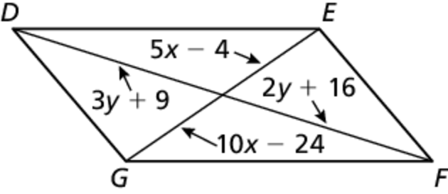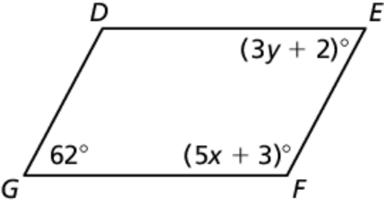 17. 18.

19. Show that the quadrilateral with vertices  and  is a parallelogram.

Classify the special quadrilateral. Explain your reasoning.

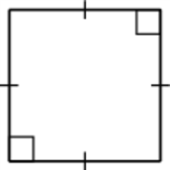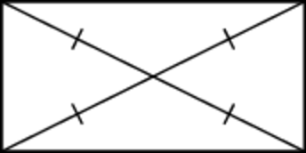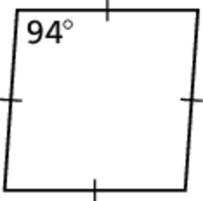 20. 21. 22.

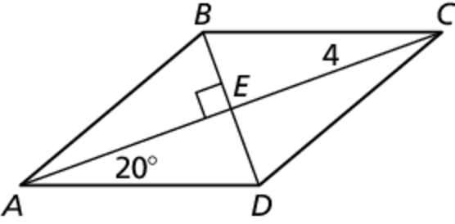The diagonals of rhombus *ABCD* intersect at *E*.   
Given that  and  find   
the indicated measure.

23.  24.  25. *AC*

Determine whether the given points represent the vertices of a trapezoid.   
If so, determine whether it is isosceles.

26. 

27. 

Find the length of the midsegment of the trapezoid.

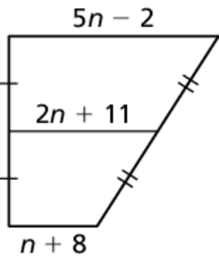 28. 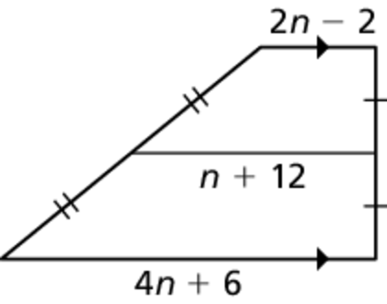 29.

In kite *ABCD*,  and  Find the indicated measure.

30. 

31. 